Angels consultant simulation guidelines

# GoPro settings and tutorial

Simulation are performed with the GoPro Hero 5 and the karma Grip to increase capture quality and stability.

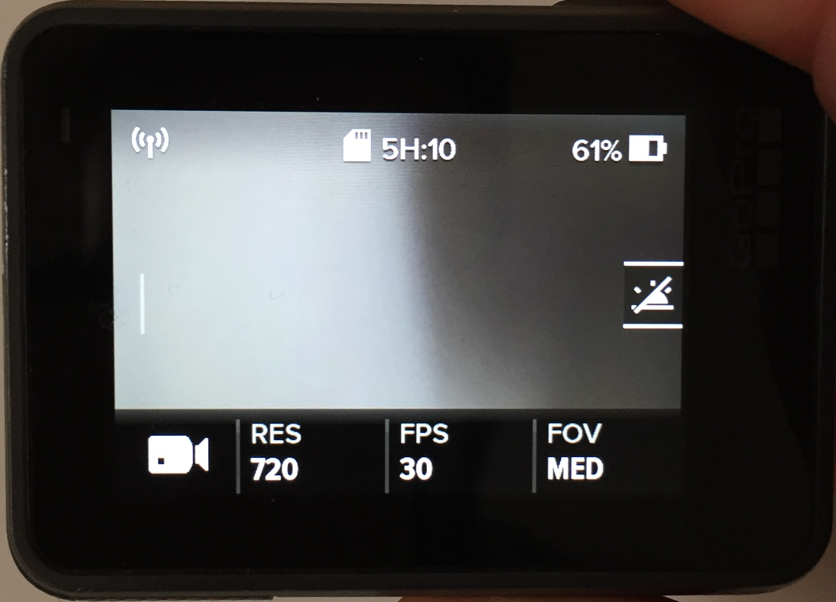In order to be able to capture long shots (over 3 hours, i.e. two simulations of 1h30min in the same hospital) use the following settings for “video mode” (*cf. Figure 1*):

**Resolution:** 720p

**Frame per second (FPS):** 30

**Field of view:** Medium

Figure 1

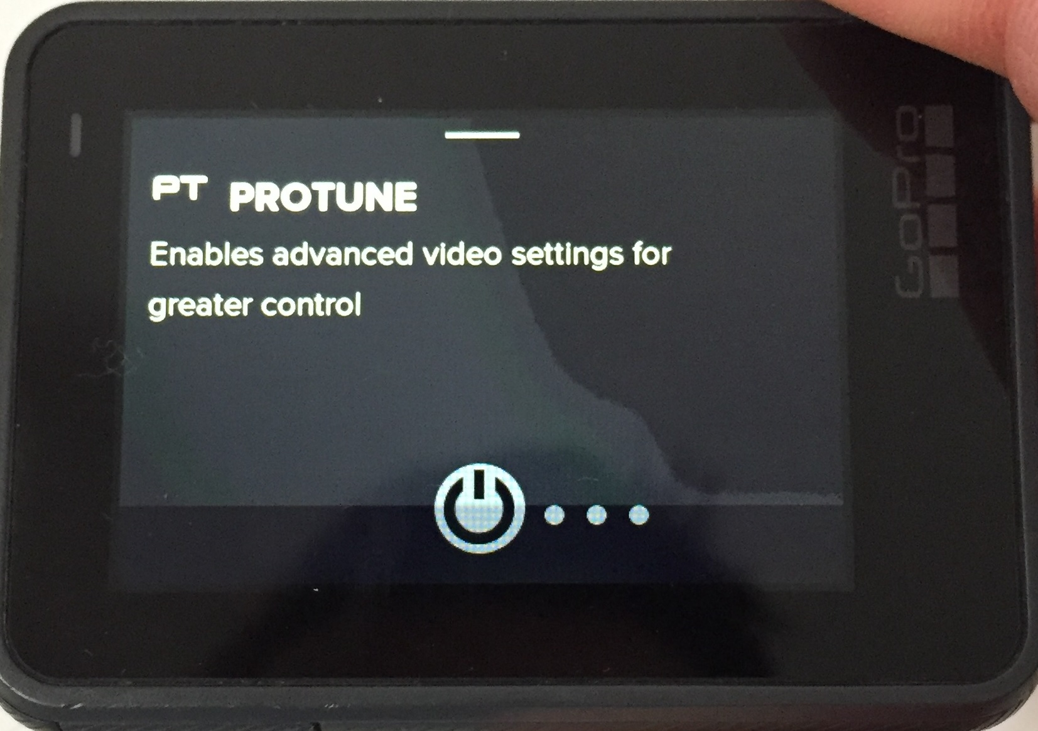You can increase your recording capacity to almost 5 hours of recording if the SD card is empty, by switching off the “Protune” settings (cf. Figure 2). Slide the screen to the left side to access the “Protune” settings.

Figure 2

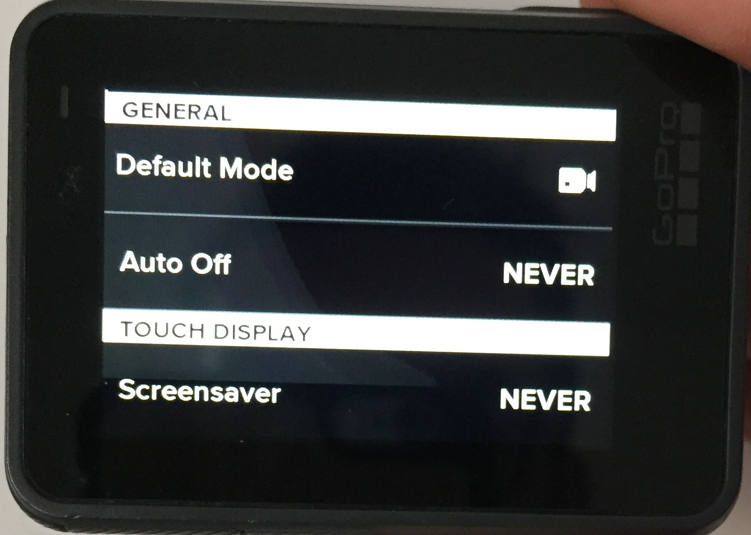If you want to see what you are recording on the GoPro screen, go to the general settings and switch off “auto off”, and the “screensaver” mode

Figure 3

(*cf. Figure 3*).

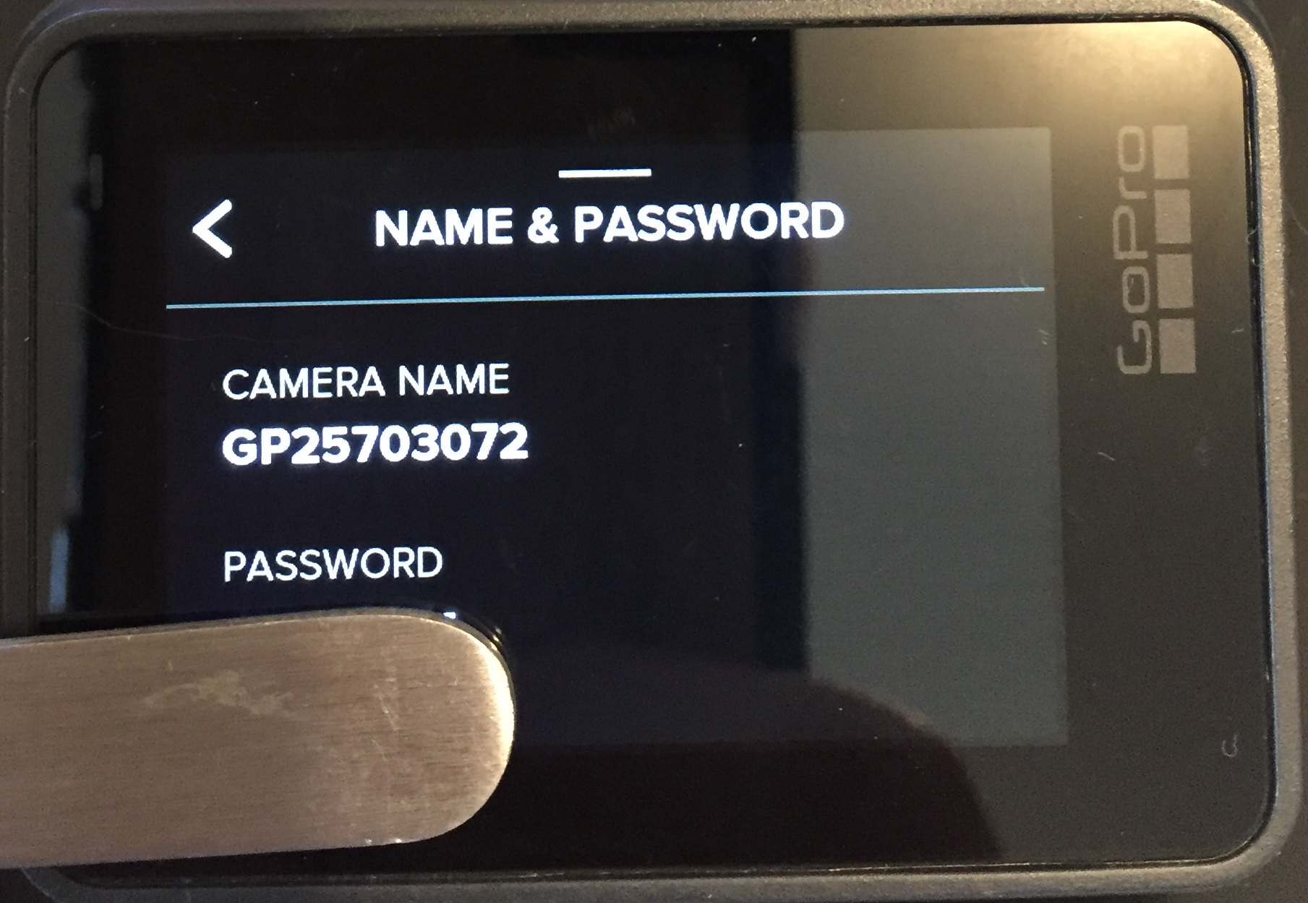

You can connect your GoPro to your iPad or iPhone by going into the “connect” settings after sliding the screen down. Then connect your i-Device to the Wi-Fi network with your GoPro’s name (here: GP 25703072) and enter the password displayed below it

*(cf. Figure 4)*

Figure 4

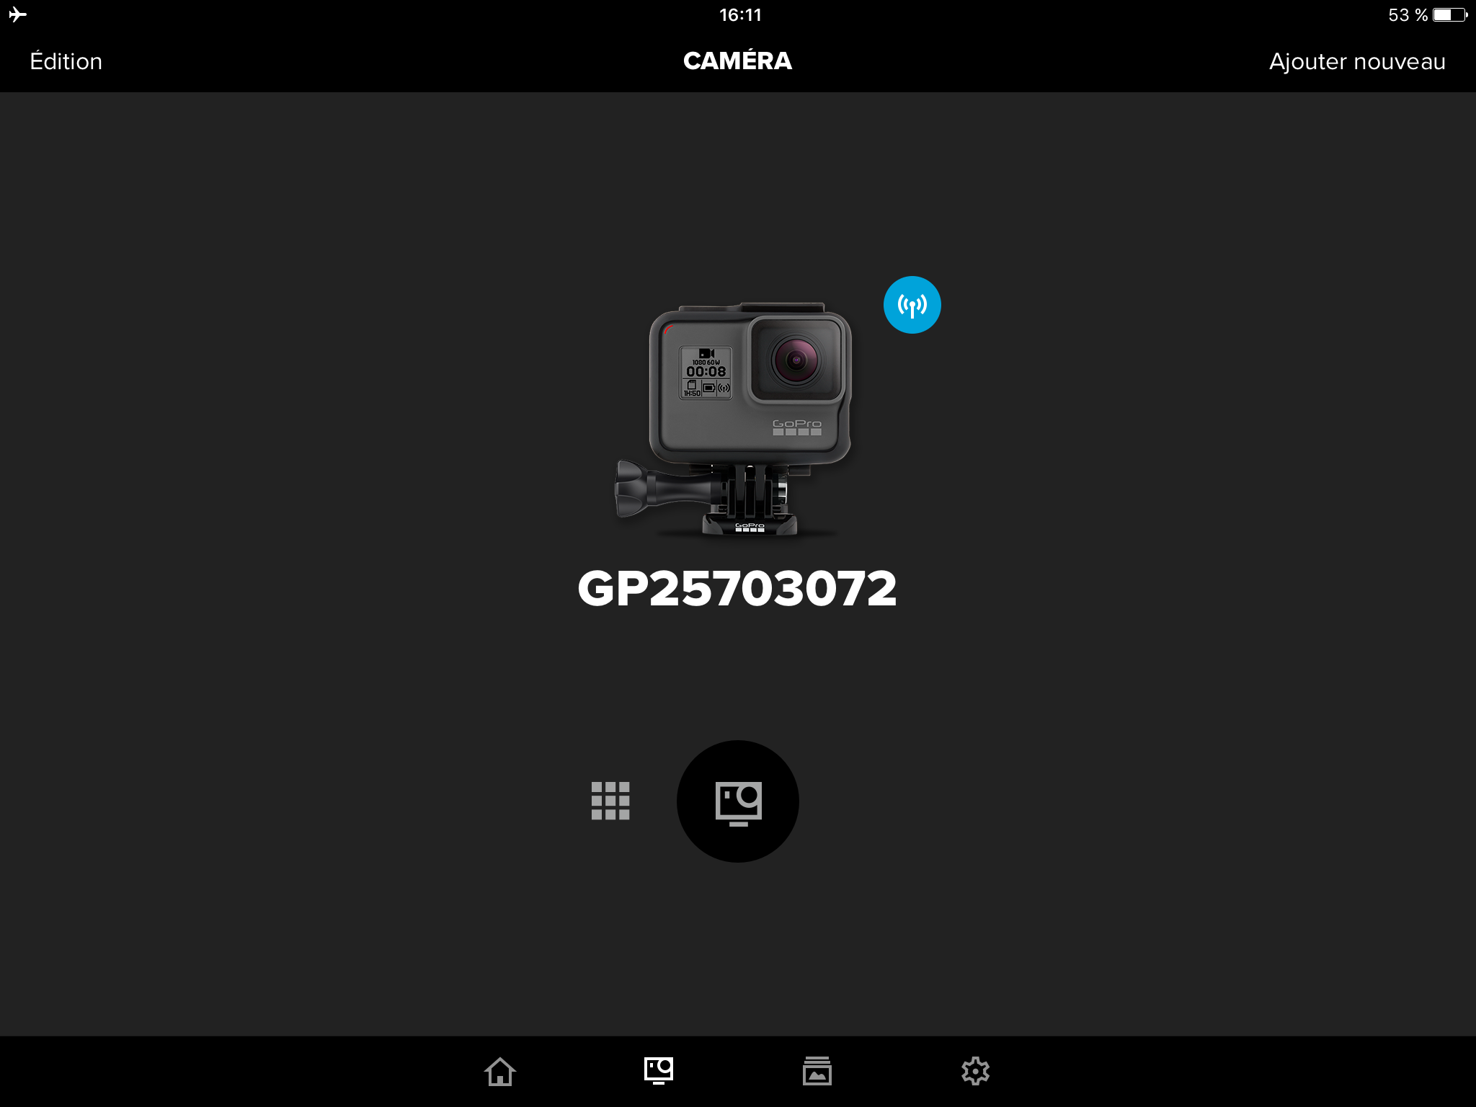Open the app named “Capture” and you should see you GoPro with a little blue wifi icon on the right corner *(cf. Figure 5)*.

Click on the media icon (bottom left side) and select your video to show it to the stroke team.

Figure 5

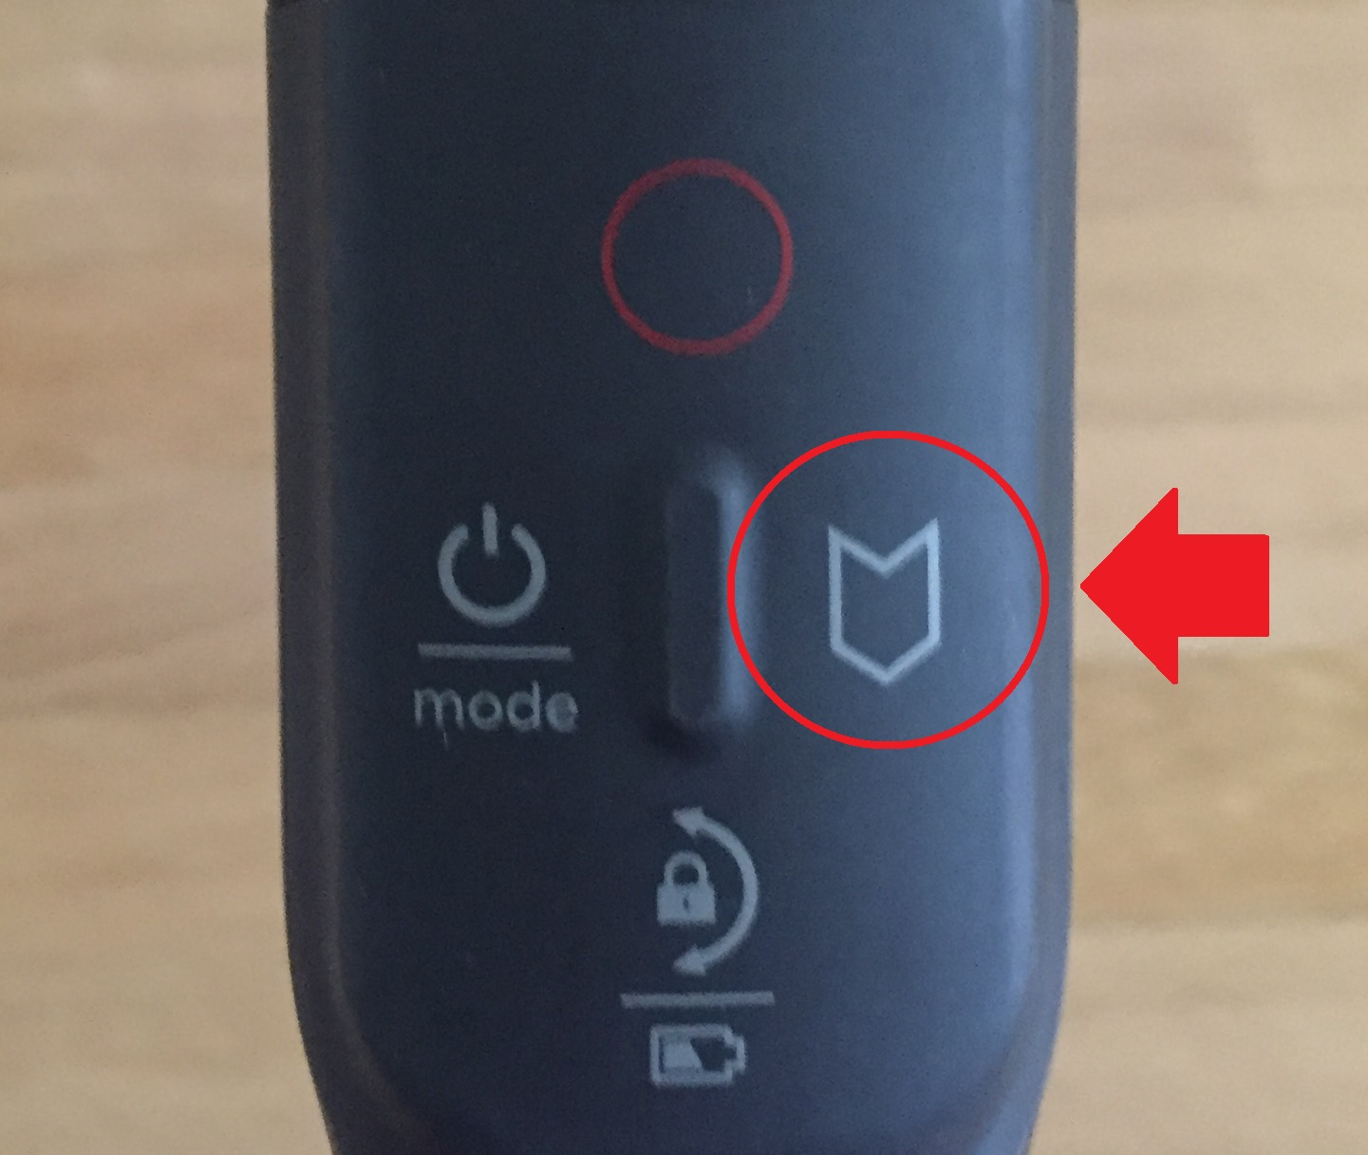

During the simulation, you can use the “highlights” button in order to mark specific moment while recording (arrival at CT scan, blood tests results, etc.) onto the video by using this button on Figure 6.

This will not stop the recording and will only add one or multiple tags on the video.

Figure 6

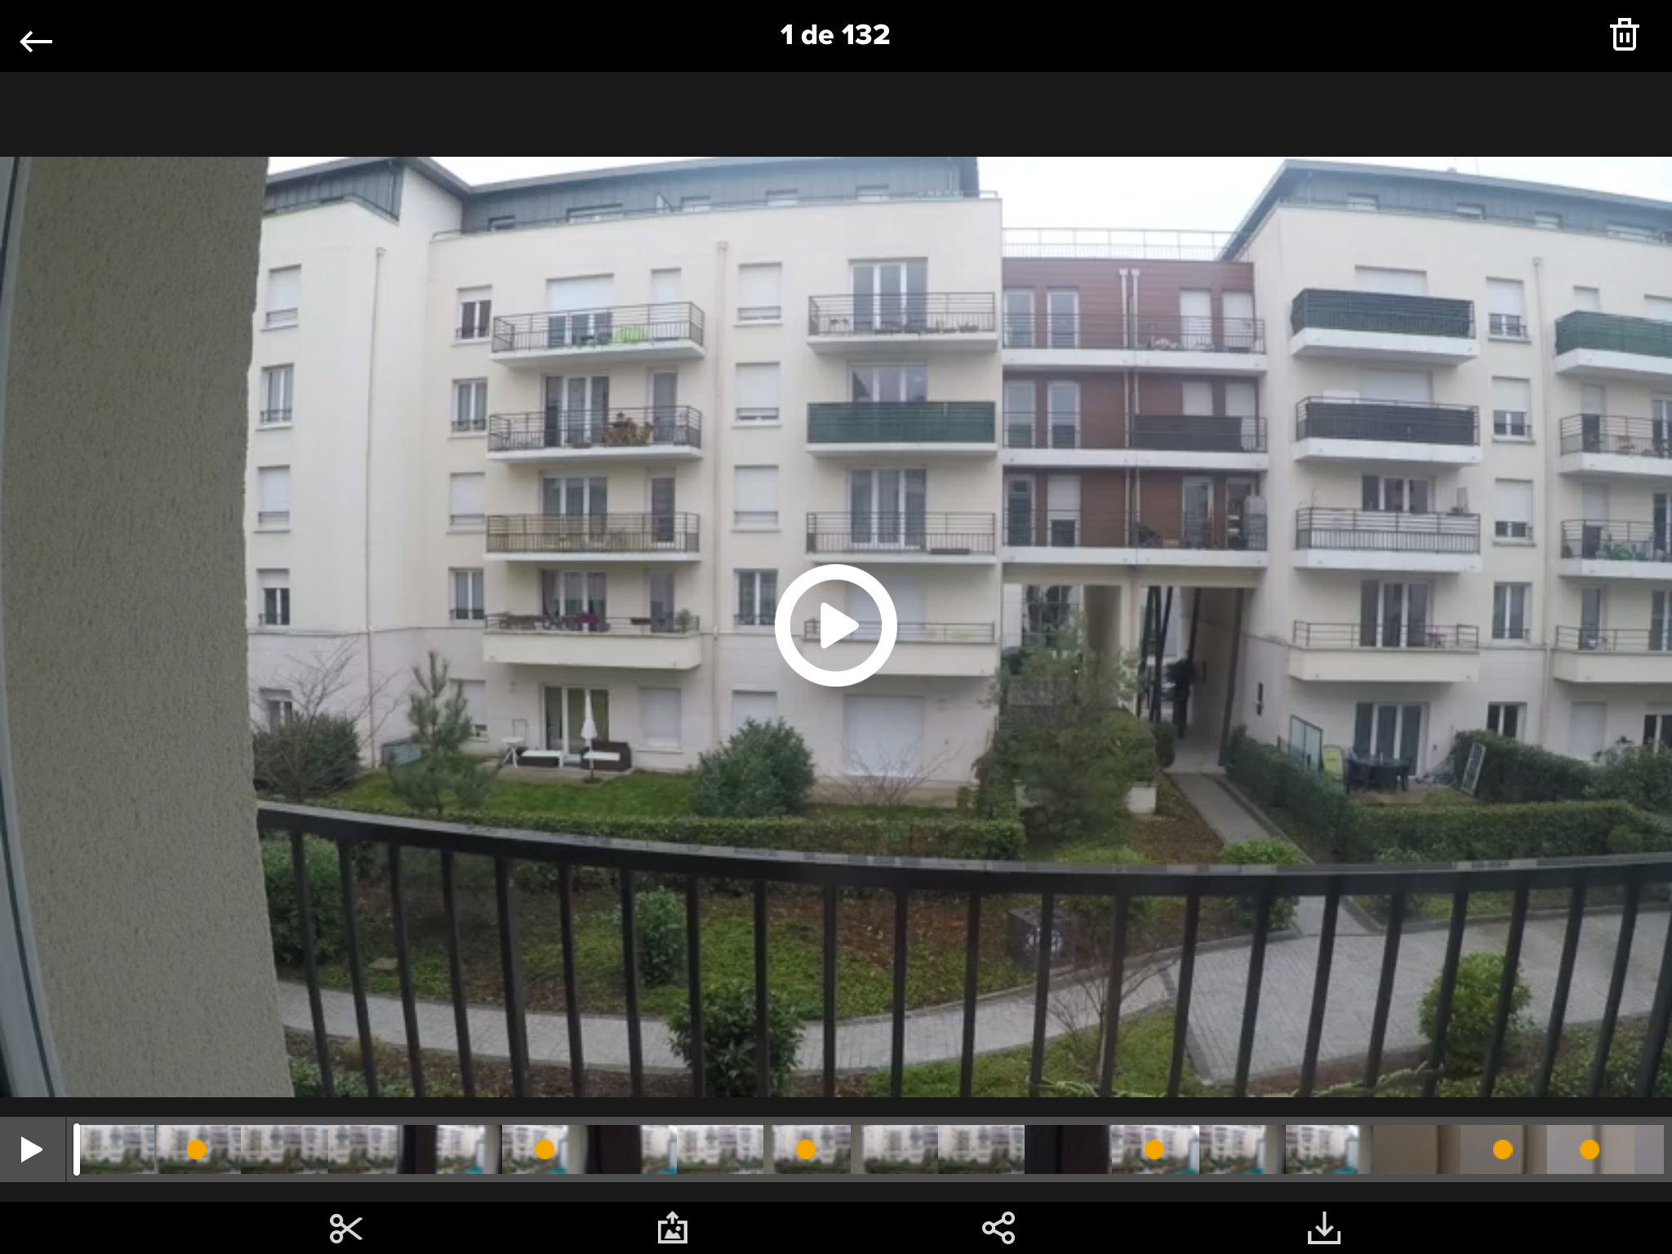Once you visualize the video on your iPad or iPhone ONLY (this feature is not available if you plug the SD card to your computer and watch the video through any player), you will see small yellow dots corresponding to the “highlights” you identified during recordings (see *Figure 7*).

Figure 7